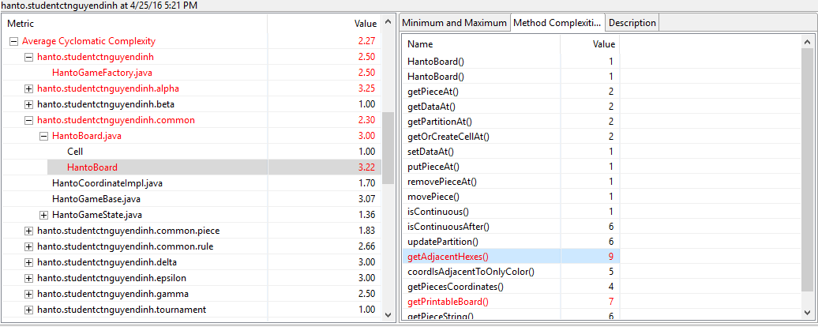

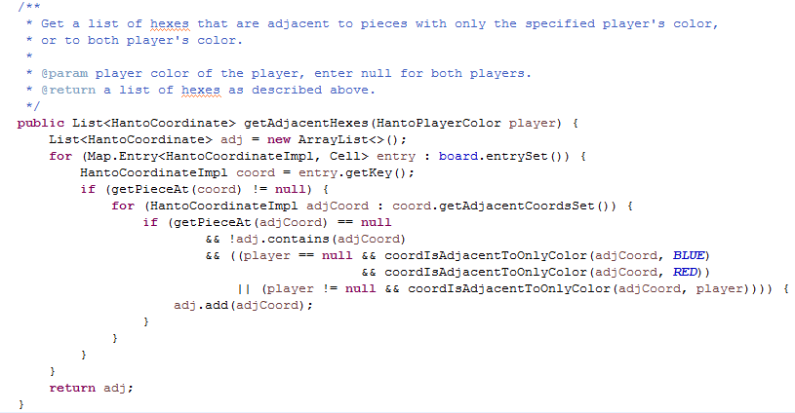

The violation is that the Average Cyclomatic Complexity of my getAdjacentHexes() method is too high. According to the description, cyclomatic complexity of a method is the measure of different paths of execution that are created by conditional statements (such as **if** and **for**) and operators (such as ?:).

As we can see in the code listed above, there are indeed some problems in my getAdjacentHexes() method. First, the **for** and **if** statements are nested in many levels, making the code hard to read. Second, the innermost **if** statement is littered with a huge conditional statement, which branches the method into multiple execution paths. A larger number of branches signifies that this method is trying to do too much.

To solve these problems, I separated the nested for-loops to two smaller loops. The first loop was then put into a helper method. Regarding the huge conditional statement, it was actually my mistake for adding redundant conditions, while I can reduce it to one single method call.

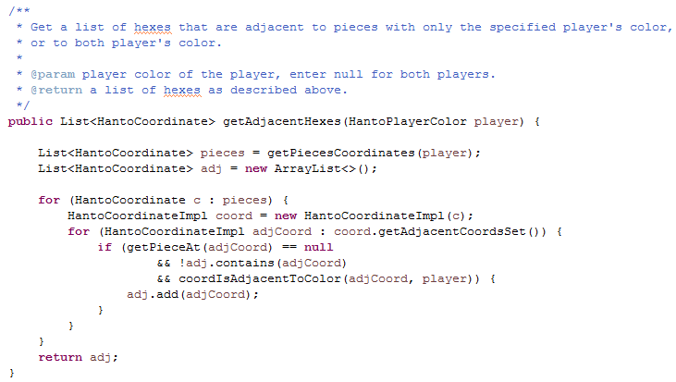

The Average Cyclomatic Complexity measure of my getAdjacentHexes() method is reduced from 9 to 4 after this change.

